**FILTRE MEDIANE 3x3**

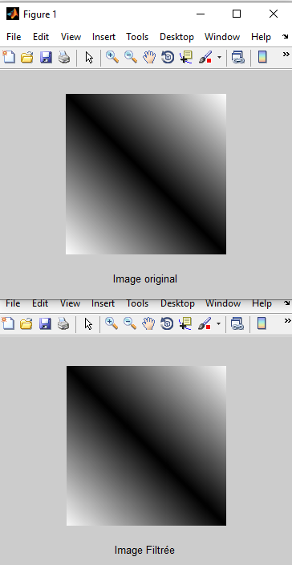

%--------------- FILTRE MEDIAN 3x3 --------------------------

clc

close all;

clear all;

for i=1:200

for j=1:200

I(i,j)=abs(i-j);

end

end

figure(1)

imshow(I, [0 200]);

xlabel('Image original');

f=5;

for i=1:200-f

for j=1:200-f

H=I(i:i+f-1,j:j+f-1);

HV = H(:);

HV= sort(HV);

Im(i,j)=HV(uint8((f^2+1)/2));

end

end

figure(2), imshow(Im, [0 200]);

xlabel('Image Filtrée');